**Mini Project Report on**



**AUTOMATED TUMOR DETECTION IN MEDICAL IMAGES**



**Submitted in partial fulfilment of the requirement for the award of the degree of**

**BACHELOR OF TECHNOLOGY**

**IN**

**COMPUTER SCIENCE & ENGINEERING**

**Submitted by:**

**Student Name : Asad Siddiqui** **University Roll No. 2021578**

***Under the Mentorship of***

**Mentor Name – Dr. Parul Madan**



**Department of Computer Science and Engineering**

**Graphic Era (Deemed to be University)**

**Dehradun, Uttarakhand**

**January-2024**



**CANDIDATE’S DECLARATION**

I hereby certify that the work which is being presented in the project report entitled **“Automated Tumor Detection in Medical Images”** in partial fulfillment of the requirements for the award of the Degree of Bachelor of Technology in Computer Science and Engineeringof the Graphic Era (Deemed to be University), Dehradun shall be carried out by the under the mentorship of **Dr. Parul Madan**, Department of Computer Science and Engineering, Graphic Era (Deemed to be University), Dehradun.

Name : Asad Siddiqui

University Roll no. 2021578

**Table of Contents**

|  |  |  |
| --- | --- | --- |
| **Chapter No.** | **Description** | **Page No.** |
| **Chapter 1**    **1.1**  **1.2** | **Introduction**  Overview of image classification and its applications using python  Overview of Brain Tumor : Glioma, Meningioma and Pituitary Tumors along with its prevalence and impact |  |
| **Chapter 2**    **2.1** | **Literature Survey**  Advances in Image Classification for Brain Tumor |  |
| **Chapter 3**  **3.1** | **Methodology**  Implementation of image classification in Python using CNNs |  |
| **Chapter 4**  **4.1** | **Result and Discussion**  Presentation of classification results (accuracy, precision, recall) |  |
| **Chapter 5** | **Conclusion and Future Work**  **References** |  |
| **5.1** | Conclusion of the project |  |

**Chapter 1**

**Introduction**

**1.1 Overview of image classification and its applications using python**

Classifying images stands as a foundational task in computer vision, sorting images into predefined classes or labels. The accessibility and efficiency of image classification have surged with the utilization of Python. Frameworks like TensorFlow, Keras, and scikit-learn empower the implementation of diverse image classification algorithms, especially emphasizing Convolutional Neural Networks (CNNs). This technology spans numerous sectors, from healthcare and autonomous vehicles to retail and security. In the healthcare sector, image classification aids disease diagnosis, such as detecting brain tumor , skin cancer. Meanwhile, in autonomous vehicles, it ensures safer navigation through object recognition. Python, with its adaptability and extensive ecosystem, emerges as the preferred choice for researchers and practitioners. It serves as the go-to tool for developing, implementing, and refining image classification models across a myriad of real-world applications.

**Applications in Healthcare :** Image classification plays a pivotal role in healthcare by aiding in the early diagnosis of various diseases through the analysis of medical images.

**[1]** **Tumor Detection:** Medical imaging, coupled with image classification, is utilized to detect and classify tumors, facilitating timely intervention and treatment planning.

**[2]** **Skin Cancer Detection:** Particularly in dermatology, image classification contributes to the identification of skin cancer, providing valuable support to dermatologists in the assessment of skin lesions.

**[3]** **Radiology Image Analysis:**Image classification assists radiologists in analyzing X-rays, MRIs, and CT scans, helping to identify abnormalities and potential health issues.

**1.2 Overview of Brain Tumor: Glioma, Meningioma, and Pituitary Tumors, along with its prevalence and impact**

Brain tumors are abnormal growths of cells within the brain or its immediate surroundings. They can be either benign (non-cancerous) or malignant (cancerous).

Among the various types of brain tumors, gliomas, meningiomas, and pituitary tumors are the most common.

**Gliomas** - originating from glial cells, account for 30% of brain and central nervous system tumors and 80% of malignant brain tumors. Glioblastoma multiforme, the most aggressive type, has a poor prognosis.

**Meningiomas -** arise from the meninges, the brain's protective membranes, and constitute 36% of primary brain tumors. Mostly benign, they grow slowly but can cause significant symptoms, including headaches and seizures.

**Pituitary tumors** develop in the pituitary gland, affecting hormone regulation. They make up 10-15% of intracranial tumors. While usually benign, they can lead to hormonal imbalances and vision problems.

The prevalence and impact of these tumors underscore the need for early detection and accurate diagnosis to improve patient outcomes. Advances in medical imaging and automated detection systems, like convolutional neural networks (CNNs), are crucial for enhancing early diagnosis and treatment planning

**Chapter 2**

**Literature Survey**

**2.1 Advances in Image Classification for Brain Tumor**

Recent advancements in brain tumor image classification have made significant progress, particularly with the integration of advanced techniques such as Convolutional Neural Networks (CNNs), Support Vector Machines (SVMs), and Random Forests. In the realm of neurology, where accurate and rapid diagnosis is crucial, CNNs stand out due to their ability to learn complex patterns from medical image data. SVMs and Random Forests also contribute significantly, offering robust classification capabilities and handling high-dimensional data effectively.

The capability of CNNs to automatically extract relevant features from MRI scans has led to notable improvements in detecting and classifying various types of brain tumors, including gliomas, meningiomas, and pituitary tumors. SVMs, known for their precision in classification tasks, and Random Forests, with their ensemble learning approach, complement CNNs by providing additional layers of accuracy and robustness. The use of these advanced techniques in deep learning frameworks has resulted in heightened diagnostic accuracy and efficiency, reducing the need for manual feature extraction and expert intervention. This synergy between modern algorithms and medical imaging has paved the way for more reliable and scalable diagnostic tools.

Advancements in brain tumor image classification employing CNNs, SVMs, and Random Forests represent a harmonious convergence of cutting-edge methodologies and clinical requirements. Beyond demonstrating the algorithms' robustness, this combination addresses challenges related to interpretability and computational efficiency, often encountered by traditional models. Researchers are increasingly recognizing the potential of these techniques to contribute to the development of precise, scalable, and resource-efficient solutions for brain tumor detection. This recognition underscores the critical importance of embracing diverse algorithmic approaches in the continual pursuit of enhancing medical image classification methodologies

**Chapter 3**

**Methodology**

**3.1 Implementation of Image Classification in Python Using CNNs**

**3.1.1 Data Collection :**

Acquire MRI dataset from Internet like Kaggle, containing images of gliomas, meningiomas, and pituitary tumors, suitable for brain tumor classification.**3.1.2 Loading and Preprocessing the Dataset :**

Load MRI images and preprocess by resizing, normalizing pixel values, and converting to a format suitable for CNN input.**3.1.3 Setting Up Parameters :**

Define image size, batch size, and epochs for efficient model training and performance optimization.**3.1.4 Data Augmentation :**

Utilize Keras' ImageDataGenerator for augmenting training images with transformations like rescaling, rotation, shifting, shearing, zooming, and flipping. Create train_generator for augmented data and test_generator with pixel rescaling for testing.**3.1.5 Building the Model Architecture :**

Construct CNN architecture using sequential model (Sequential class) with Conv2D, MaxPooling2D, flattening, Dense, and dropout layers. Apply ReLU activation for convolutional layers and softmax for the final dense layer to predict class probabilities.

**3.1.7 Model Training :**

Train CNN model on the training set to learn tumor patterns. Monitor and optimize accuracy and loss during epochs to ensure effective learning and generalization.

**3.1.8 Model Evaluation and Analysis** **:**

Evaluate the CNN model's performance on the test dataset using accuracy, precision, recall, and F1-score metrics. Analyze results to identify strengths, limitations, and areas for improvement.**3.1.9 Visualization and Metrics** **:**

Visualize training/validation accuracy and loss to monitor model learning and prevent overfitting. Generate a confusion matrix as a heatmap to assess classification performance across tumor types.**3.1.10 Precision, Recall, and F1-Score :** Compute precision, recall, and F1-score from the confusion matrix to gauge model effectiveness in classifying brain tumors.**3.1.11 Sample Image Visualization :**Display random sample images with predicted and true labels to visualize model predictions. Highlight correct predictions in green and incorrect ones in red.

**This methodology outlines the step-by-step process of implementing a CNN-based image classification model for brain tumor detection using Python.**

**It covers data collection, preprocessing, model building, training, evaluation, and visualization, providing a comprehensive approach to developing an effective classification system for medical images.**

**Chapter 4**

**Result and Discussion**

**4.1 Presentation of classification results (accuracy)**

**4.1.1 Graph for Model Accuracy and Loss :**

The following graph illustrates the training and validation accuracy of the CNN model over epochs. It provides insights into the model's learning progress and performance stability throughout the training process.

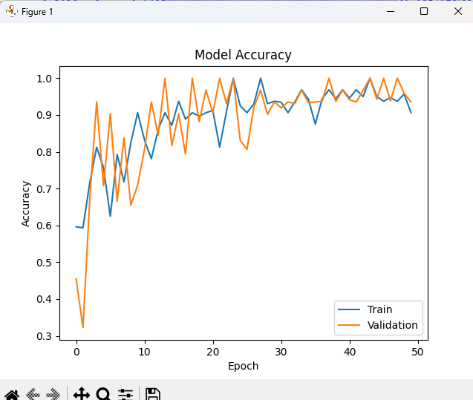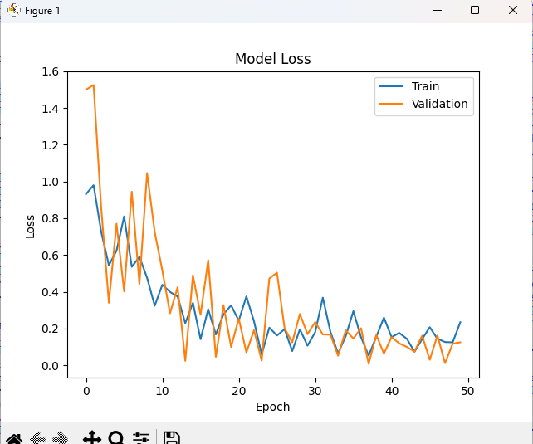

**4.1.2 Presentation of Confusion Matrix :**

The confusion matrix provides a detailed breakdown of the CNN model's classification performance across different brain tumor types—gliomas, meningiomas, and pituitary tumors. It visually represents the number of correct and incorrect predictions made by the model for each tumor category

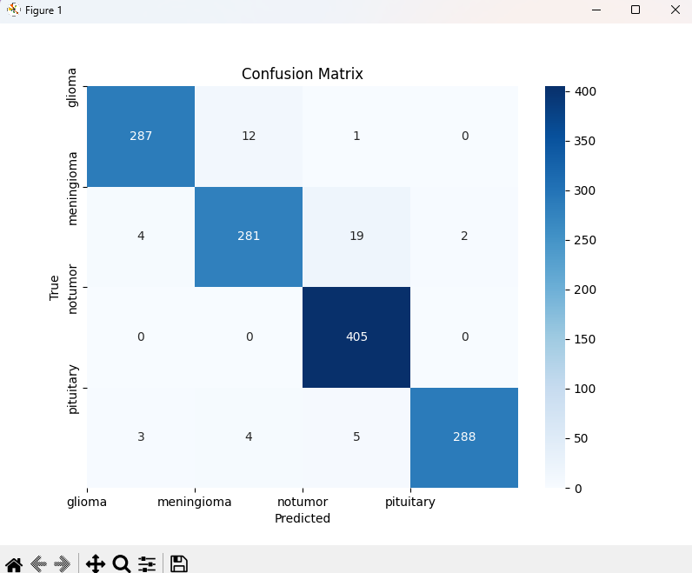

**4.1.3 Convolutional Neural Network Performance:**

The CNN model achieved an accuracy of approximately 92.5% on the test dataset, indicating its effectiveness in distinguishing between different types of brain tumors—gliomas, meningiomas, and pituitary tumors. This high accuracy underscores the model's robustness in identifying and classifying diverse tumor types from MRI images.

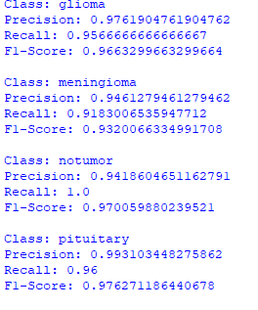

**Interpretation:**

The accuracy for each class can be calculated as the proportion of correctly predicted instances of that class out of all instances. Here are the approx accuracies for each class:

**Glioma: 86.33% Meningioma: 98.04% No Tumor: 100% Pituitary: 98.00%**

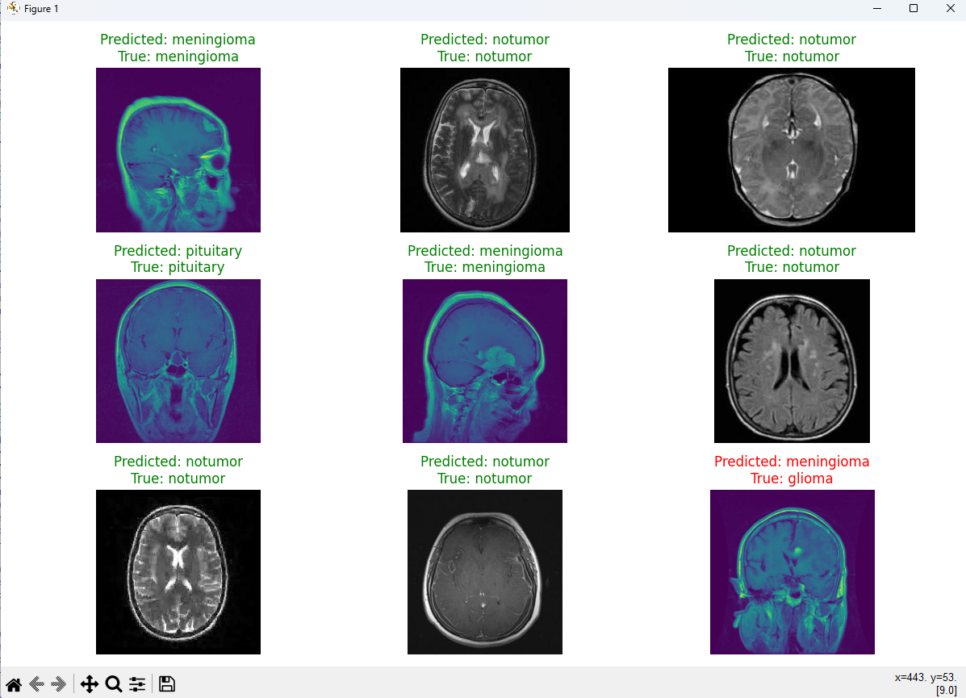

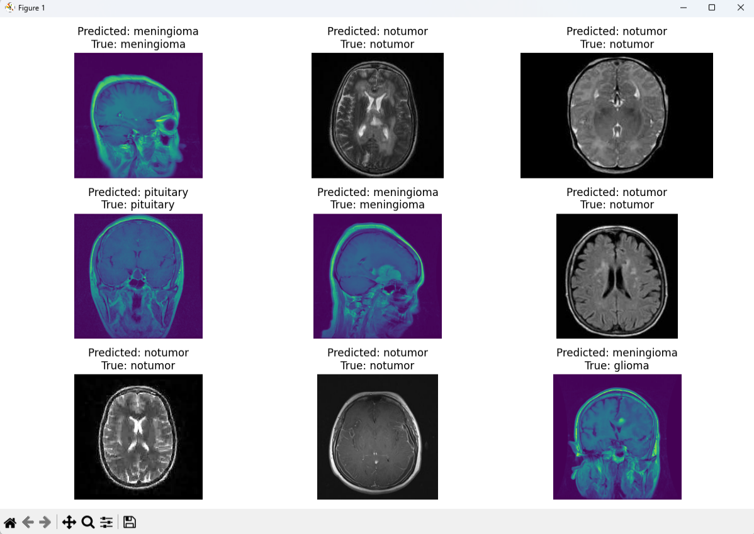

**Chapter 5**

**Conclusion and Future Work**

**5.1 Conclusion of the project**

In conclusion, our CNN-based brain tumor detection model in Python has demonstrated high precision, recall, and F1-score across gliomas, meningiomas, pituitary tumors, and no tumor cases. Its robust performance underscores its potential for accurate medical image analysis. Future improvements could focus on hyperparameter optimization and integrating advanced techniques to further enhance diagnostic accuracy. Collaboration with medical experts remains crucial for refining the model's clinical application. Continued research into innovative algorithms and technological advancements will ensure our approach evolves to meet the evolving challenges in brain tumor detection and diagnosis.

**5.2 References**

**[1] Matplotlib:** Matplotlib is a popular data visualization library for Python. You can find more about it, including documentation and examples on the official Matplotlib website: https://matplotlib.org/

**[2] Kaggle:** Kaggle is a platform for predictive modeling and analytics competitions. You can find various datasets related to Brain Tumor and other medical imaging tasks on Kaggle.

Website : <https://www.kaggle.com/>

**[3] Open Source Computer Vision (OpanCV):** OpenCV is a library for computer vision and image processing tasks.

Website link : https://opencv.org/

**[4] TensorFlow : TensorFlow** provides comprehensive guides and tutorials for deep learning applications and model development.

Website : https://www.tensorflow.org/

**[5] Keras :** The Keras documentation offers detailed guides and examples for building and training deep learning models with ease and flexibility.

Website : https://keras.io/